 | Sultan Qaboos University  College of Nursing  Bachelor of Science in Nursing (BSN)  Course Outline | 

 | Sultan Qaboos University | College of Nursing
Vision | To continue its national leading role in higher education and community service and also to be internationally recognized for innovative research, quality of its graduates, and strategic partnerships. |  | To be recognized, nationally and internationally, as the premier institute for developing and delivering innovative nursing education, cutting edge research, transformative community service, and effective partnerships.
Mission | To excel in teaching and learning, research and innovation, and community service by promoting the principles of scientific analysis and creative thinking in a collegial and stimulating environment and to participate in the production, development and dissemination of knowledge and interact with national and international communities |  | To provide high-quality education in nursing in a learning-promoting environment, to advance healthcare knowledge and practice through research and other scholarly activities, and to provide collaborative community services that can inspire the people in Oman to achieve health, wellness, and quality of life.
Core Values | ◆ Excellence ◆ Loyalty ◆ Integrity ◆ Credibility  ◆ Equity ◆ Commitment ◆ Collegiality |  | ◆Well-being ◆Excellence ◆Commitment  ◆Accountability ◆Respect◆ Empathy

I. Course Information
Course Code
Course Title
Oman Qualification Framework (Oqf) Level
Credit Hours
Contact Hours
Pre-Requisites
Co-Requisites
Equivalent Courses
Incompatible Courses
Course Category | University Requirement |  | University Requirement
 | College Requirement |  | College Requirement
 | Department Requirement |  | Department Requirement
 | Specialization Requirement |  | Specialization Requirement
 | Other (specify): |  | Other (specify):
Course Owner | College: |  | Department:
 | Center: |  | Unit:
Delivery Mode | □ Face to Face | □ Blended |  | □ Online
Course Type | Lecture |  | Lecture/Lab
 | Lecture/Seminar |  | Lecture/Studio
 | Lecture/Tutorial |  | Lecture/Lab/Tutorial or Seminar
 | Tutorial |  | Laboratory (Practical)
 | Field or Work Placement |  | Studio
 | Seminar |  | Internship
 | Workshop |  | Project
 | Thesis |  | Other (specify):
Language Of Instruction
Course Description
Teaching And Learning Strategies | Augmented Reality |  | Flipped Classroom
 | Blended Learning |  | Problem-Based Learning
 | Discovery-Based Learning |  | Project-Based Learning
 | Student-Led Learning |  | Team-Based Learning
 | Work-Based Learning |  | Other (specify):
Assessment Component And Weight | In-term examination(s) ( %) |  | Quizzes ( %) |  | Other (specify):  ( %)
 | Homework assignments ( %) |  | Project ( %)
 | Final examination ( %) |  | Practical/ Lab (%)
Textbooks And Educational Material
Grading Method | A-F Scale | Pass/Not Pass |  | Other (specify):
Grading Scale | Letter Grade | Numeric Value | Range | Description
 | A | 4.0 | ≥ 90.0% | Exceptional performance
 | A ⁻ | 3.7 | 87.0 - 89.9
 | B ⁺ | 3.3 | 83.0 - 86.9 | Very good performance
 | B | 3.0 | 80.0 - 82.9
 | B ⁻ | 2.7 | 77.0 - 79.9
 | C ⁺ | 2.3 | 73.0 - 76.9 | Satisfactory performance
 | C | 2.0 | 70.0 - 72.9
 | C ⁻ | 1.7 | 67.0 - 69.9
 | D ⁺ | 1.3 | 63.0 - 66.9 | Minimally acceptable performance
 | D | 1.0 | 60.0 – 62.9
 | F | 0.0 | < 60.0 | Unacceptable performance

II. Mapping and Matching the Course Learning Outcomes (CLO), Program Learning Outcomes (PLO), Graduate Attributes (GA), and competencies

Course Learning Outcomes | EPSLO* |  |  | SQU GA§ | AACN | QSEN ^{ϒ}
 | I | R | E
- Understand the role of biostatistics in nursing studies. | 1 |  |  | A | 1
- summarize and display data from nursing studies useing descriptive tools. |  | 7 |  | A3 | 7
- Identify appropriate tests to perform hypothesis testing, and interpret the outputs adequately |  | 7 |  | A3 | 7
- Interpret descriptive and inferential statistics results and find relative conclusions. |  | 8 |  | B2 | 9 | Informatics
- Understand the fundamental concepts of epidemiology and its role in nursing research | 1 |  |  | A1 | 1
- Identify ways to describe epidemiologic data according to place, time, and person. | 1 |  |  | A1 | 1
- Apply basic epidemiological concepts to current health problems. |  | 7 |  | A3 | 7

OQF Characteristics | OQF Level | Rationale
Knowledge
Skills
Communication, Numeracy, Information Communication Technology (ICT) Skills
Autonomy and Responsibility
Employability and Values
Learning to Learn
Overall Level

Mapping and Matching the Course Learning Outcomes (CLO), teaching activities, assessment type and methods
CLO | Teaching Activities | Assessment type (Formative, Summative) | Assessment Methods
Total

IV. Course Learning Outcomes (CLOs) and Assessment Criteria and Methods (for each CLO)
CLO1:
Assessment Criteria (to achieve this objective, the student must) |  | Assessment Methods
A)
B)
C)
CLO2:
Assessment Criteria (to achieve this objective, the student must) |  | Assessment Methods
A)
B)
C)
CLO3:
Assessment Criteria (to achieve this objective, the student must) |  | Assessment Methods
A)
B)
C)
CLO4:
Assessment Criteria (to achieve this objective, the student must) |  | Assessment Methods
A)
B)
C)

Notional Learning Hours for the module
Activity |  | Notional Learning Hours
Contact hours | Lectures/Class/ Seminars/Tutorials
 | Practical/Laboratory
 | Field Work
Assessment
Independent Learning, including research and revision for assessment
Other (specify)
Total Notional Learning Hours
Proposed number of OQF Credit Hours

II. Semester Information
Semester/Year |  | Section(s)
Day and Time |  | Venue(s)
Course Coordinator |  | Course Team
Coordinator Office |  | Office Hours
Coordinator Extension |  | Coordinator Email

V. Course Content and Schedule
Week | Lectures # | Topics/ Subjects | Readings/ chapters | Remarks (e.g., assessments)
1
2
3
4
5
6
7
8
9
10
11
12
13
14
15
16

VI. Additional Information (e.g., Rubrics, etc.)

VII. Students Responsibilities
It is the student’s responsibility to know and comply with all University Academic Regulations relevant to participation in this course. These regulations specifically include attendance requirements and student academic code of conduct.
Academic Integrity | The University expects the Students to approach their academic endeavors with the highest academic integrity. Students should review the Student Academic Misconduct Policy available on this link.
Add and Drop | Students who wish to drop or add the course should review the Registration Regulation (B-2) in the Undergraduate Academic Regulations, which can be found on the Deanship of Admission and Registration’s webpage (link) and the Student Handbook.
Attendance | Sultan Qaboos University has a clear requirement for students to attend courses. Students should review the Attendance Policy (B-6) in the Undergraduate Academic Regulations, which can be found on the Deanship of Admission and Registration’s webpage (link) and the Student Handbook.
Assessment and Grading | To ensure the provision of a sound and fair assessment and grading, Sultan Qaboos University has issued the Undergraduate Academic Assessment Policy available on this link.
Grievance | Students who wish to appeal their grades should review the grade appeal procedure under the Undergraduate Academic Assessment Policy available on this link.
Classroom Policies | Students are expected to dress professionally during class time as required by the University and any rules in the Student Handbook. Use of phones or any other electronic devices in the classroom during class time is strictly prohibited. Unauthorized use may lead to faculty member confiscation of the device for the remainder of the class. Behavior that persistently or grossly interferes with classroom activities is considered disruptive behavior and may be subject to disciplinary action. A student responsible for disruptive behavior may be required to leave the class. More information is available on the Student Academic Misconduct Policy available on this link.
Late and Make-Up Work | Students are required to meet the course objectives by submitting coursework no later than the assigned due date. Students may be allowed to submit late work if approved by the course coordinator. Assignments submitted after the due date may be penalized.
Missed Evaluations | All quizzes, tests, clinical evaluations, and exams must be completed by the date they are assigned. If a quiz, test, or exam is missed due to a documented emergency situation (e.g., death in the immediate family), it is the student’s responsibility to contact the instructor within 24 hours of the original due date and follow the policies for missed work. Students who do not make up the quiz, test, or assessment as scheduled or who do not contact the instructor within 24 hours will receive a zero score for that assessment.
Clinical Policies | Review the clinical and laboratory policies included in the Student Handbook.

Appendix C

End of Program Student Learning Outcomes
- Integrate knowledge from various courses into nursing.
- Provide ethical nursing care to individuals, families and community
- Ensure safety in the care of individuals, families and community
- Adopt evidence-based practice in the care of individuals, families and community
- Demonstrate leadership and team skills in health care.
- Communicate effectively with patient, family and multidisciplinary health care team
- Adopt critical thinking in Nursing practice
- Demonstrate ability to learn independently

SQU Graduate Attributes

- Cognitive Capabilities: The graduate has sufficient general and specialized theoretical knowledge that enables him/her to deal well with his/her specialty and other related fields.
- Skill and professional capability: The graduate has sufficient skill and practical experience that enables him/her to perform all tasks related to the specialization and other related fields.
- Effective communication: The graduate has the ability to communicate effectively with others to achieve the desired results.
- Autonomy & leadership: The graduate has the ability to lead, analyze, make decisions and take responsibility for decisions.
- Responsibility & commitment: The graduate appreciates the importance of available resources and deals with them effectively, and is committed to the ethics of the profession and society.
- Development & innovation: The graduate has a passion for development and innovation in his/her field of specialization.

AACN Essentials

Domain 1: Knowledge For Nursing Practice
Domain 2: Person-Centered Care
Domain 3: Population Health
Domain 4: Scholarship For the Nursing Discipline
Domain 5: Quality And Safety
Domain 6: Interprofessional Partnerships
Domain 7: Systems-Based Practice
Domain 8: Informatics And Healthcare Technologies
Domain 9: Professionalism
Domain 10: Personal, Professional, And Leadership Development

D. QSEN COMPETECIES
Patient-Centered Care | Teamwork and Collaboration | Evidence-Based Practice
Quality Improvement | Safety | Informatics

Table 1. Mapping the EPLO, AACN essentials, QSEN competencies and SQU Graduate Attributes
EPLOS | AACN Essentials | QSEN COMPETENCIES | SQU Graduate Attributes | Role Specific Competencies | OQF
- Integrate knowledge from various courses into nursing. | Domain 1 | ----- | 1 | Knowledgeable | Knowledge
- Provide ethical nursing care to individuals, families and community | Domain 2 | Patient-centered care | 5 | Ethical | Employability and value
- Ensure safety in the care of individuals, families and community | Domain 5 Domain 3 | Safety | 5 | Safe Clinician | Employability and value
- Adopt evidence-based practice in the care of individuals, families and community | Domain 4  Domain 8 | Evidence-based Practice | 2 | Evidence – Oriented | Skills
- Demonstrate leadership and team skills in health care. | Domain 10 | Quality Improvement | 4 | Leader | Autonomy and Responsibility
- Communicate effectively with patient, family and multidisciplinary health care team | Domain 6 | Teamwork and Collaboration | 3 | Communicator | Communication, Numeracy, ICT Skills
- Adopt critical thinking in Nursing practice | Domain 7 | ------- | 4 | Critical Thinker | Skills
- Demonstrate ability to learn independently | Domain 9 | Informatics | 6 | Independent Learner | Learning to Learn

Role Specific Competencies
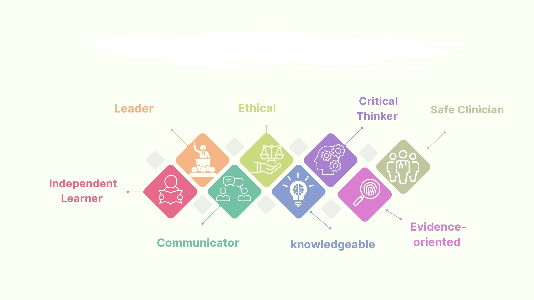

Quality Check

 | Yes | NO
Does the title of the module reflect its content?
Is the module written in learning outcomes?
Are the learning outcomes clear and unambiguous?
Are the pre-requisite and/or co-requisites (if any) clearly identified?
Are all the learning outcomes assessed?

Date of amendments (revisions) of this course
Version No. | Date | Notes | Prepared by | Revised by | Approved |  | Date
 |  |  |  |  | Department | Curriculum committee

